**[Os Vários Tipos de Coridoras](http://coridoras.blogspot.com.br/2008/10/os-vrios-tipos-de-coridoras.html)**

[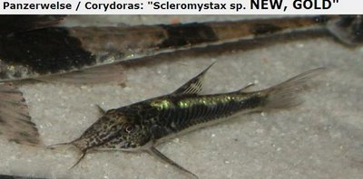](http://3.bp.blogspot.com/_JBpekKB3BH8/SQmYlUcmgXI/AAAAAAAAAsk/ck1vXEwbW14/s1600-h/imagem77.JPG)

[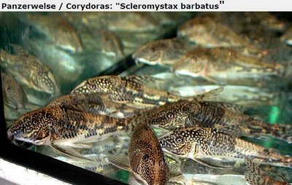](http://2.bp.blogspot.com/_JBpekKB3BH8/SQmYlKzmWEI/AAAAAAAAAsc/3stqkcSepak/s1600-h/imagem76.JPG)[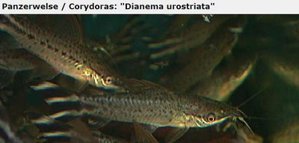](http://4.bp.blogspot.com/_JBpekKB3BH8/SQmYaGk0mTI/AAAAAAAAAsU/oYVeWEmtL2s/s1600-h/imagem75.JPG)

[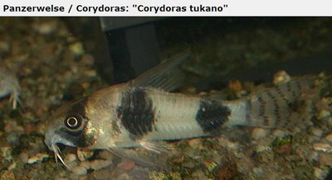](http://4.bp.blogspot.com/_JBpekKB3BH8/SQmYZzLZkQI/AAAAAAAAAsM/9ReQ0XV_XiU/s1600-h/imagem74.JPG)

[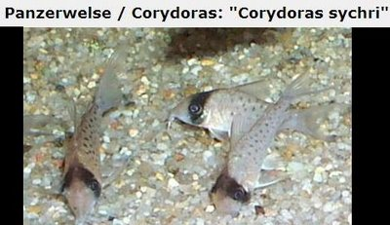](http://2.bp.blogspot.com/_JBpekKB3BH8/SQmYZnHQsjI/AAAAAAAAAsE/LIJ3XISw5TY/s1600-h/imagem73.JPG)

[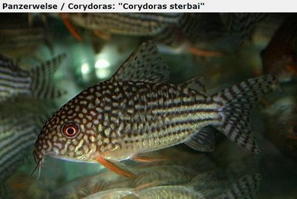](http://1.bp.blogspot.com/_JBpekKB3BH8/SQmYZWFQGxI/AAAAAAAAAr8/gIp6E0H8syI/s1600-h/imagem72.JPG)

[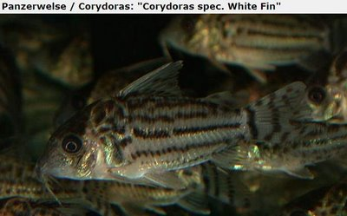](http://3.bp.blogspot.com/_JBpekKB3BH8/SQmYZLh35TI/AAAAAAAAAr0/Mn6EV_Ccc3s/s1600-h/imagem71.JPG)

[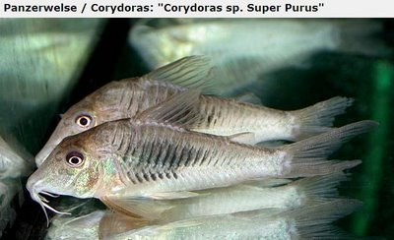](http://4.bp.blogspot.com/_JBpekKB3BH8/SQmYNhhyfxI/AAAAAAAAArs/IAflnnP_cFQ/s1600-h/imagem70.JPG)

[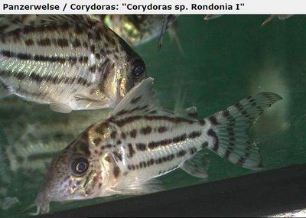](http://3.bp.blogspot.com/_JBpekKB3BH8/SQmYNMs_DfI/AAAAAAAAArk/VgBKyUBauuY/s1600-h/imagem69.JPG)

[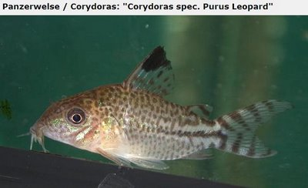](http://1.bp.blogspot.com/_JBpekKB3BH8/SQmYNBgZBaI/AAAAAAAAArc/BYUyjLc8v_Y/s1600-h/imagem68.JPG)

[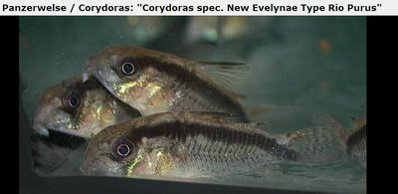](http://3.bp.blogspot.com/_JBpekKB3BH8/SQmYNH2_QfI/AAAAAAAAArU/cmEmsn3R7DE/s1600-h/imagem67.JPG)

[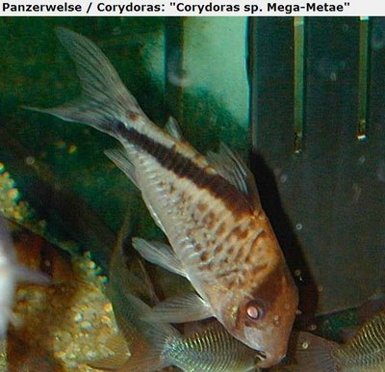](http://1.bp.blogspot.com/_JBpekKB3BH8/SQmYM1mOuCI/AAAAAAAAArM/R6BGdCKlWuM/s1600-h/imagem66.JPG)

[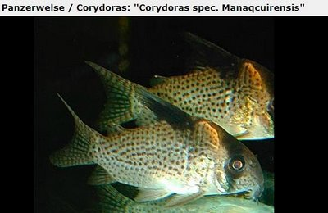](http://4.bp.blogspot.com/_JBpekKB3BH8/SQmYBWpLfpI/AAAAAAAAArE/xgZnui5H2Ns/s1600-h/imagem65.JPG)

[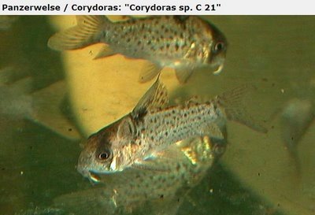](http://3.bp.blogspot.com/_JBpekKB3BH8/SQmYBEsT-9I/AAAAAAAAAq8/oOk0Pt1r9KI/s1600-h/imagem64.JPG)

[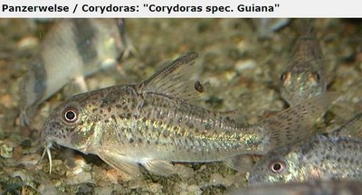](http://4.bp.blogspot.com/_JBpekKB3BH8/SQmYBMxkcFI/AAAAAAAAAq0/RUdbthh4QQI/s1600-h/imagem63.JPG)

[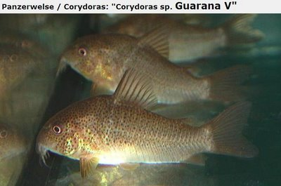](http://3.bp.blogspot.com/_JBpekKB3BH8/SQmYA-EAwVI/AAAAAAAAAqs/DUdIuuBtJtE/s1600-h/imagem62.JPG)

[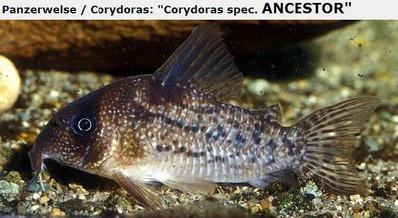](http://3.bp.blogspot.com/_JBpekKB3BH8/SQmX1JWD9wI/AAAAAAAAAqc/X0G89_Hs3ck/s1600-h/imagem60.JPG)

[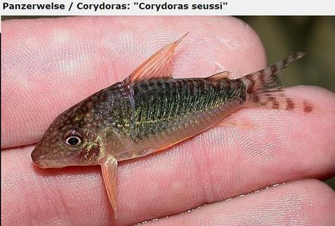](http://1.bp.blogspot.com/_JBpekKB3BH8/SQmX05kyjuI/AAAAAAAAAqM/ZjP8qXoXwhc/s1600-h/imagem58.JPG)

[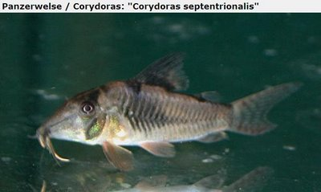](http://2.bp.blogspot.com/_JBpekKB3BH8/SQmX0wJb4SI/AAAAAAAAAqE/UHDzyzwO0kU/s1600-h/imagem57.JPG)

[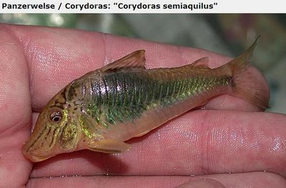](http://4.bp.blogspot.com/_JBpekKB3BH8/SQmX0pZWhNI/AAAAAAAAAp8/8jyExcVRiA4/s1600-h/imagem56.JPG)

[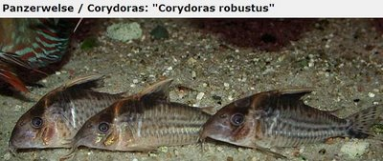](http://4.bp.blogspot.com/_JBpekKB3BH8/SQmXp08hZxI/AAAAAAAAAp0/RbFgwxaoihg/s1600-h/imagem55.JPG)

[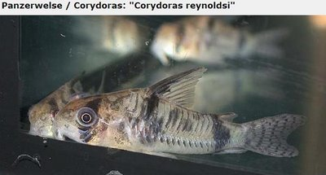](http://1.bp.blogspot.com/_JBpekKB3BH8/SQmXpa1YqEI/AAAAAAAAApk/qKD19Peqzec/s1600-h/imagem53.JPG)

[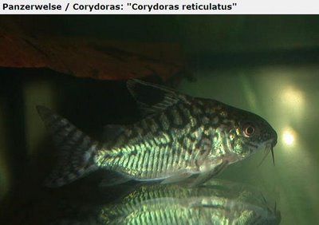](http://4.bp.blogspot.com/_JBpekKB3BH8/SQmXpPWU6mI/AAAAAAAAApc/qBqZ8K_yS7Q/s1600-h/imagem52.JPG)

[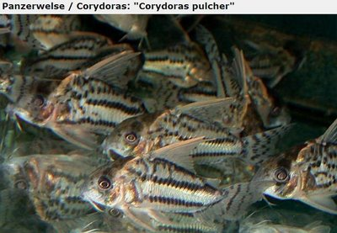](http://2.bp.blogspot.com/_JBpekKB3BH8/SQmXoIia2RI/AAAAAAAAApU/WzgX79JCLbw/s1600-h/imagem51.JPG)

[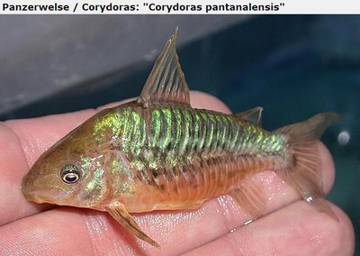](http://2.bp.blogspot.com/_JBpekKB3BH8/SQmXXEXey4I/AAAAAAAAApM/tP_xldn9qAY/s1600-h/imagem50.JPG)

[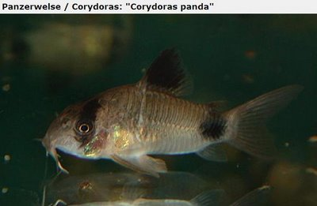](http://4.bp.blogspot.com/_JBpekKB3BH8/SQmXW5jt1oI/AAAAAAAAApE/d1H1y69SNdk/s1600-h/imagem49.JPG)

[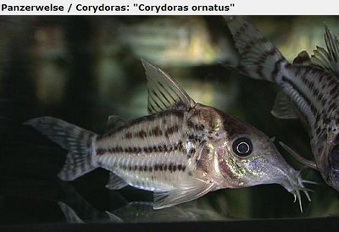](http://4.bp.blogspot.com/_JBpekKB3BH8/SQmXWqaCabI/AAAAAAAAAo8/OEou9ZAAjEs/s1600-h/imagem48.JPG)

[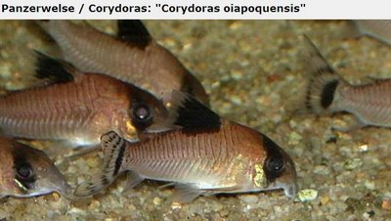](http://1.bp.blogspot.com/_JBpekKB3BH8/SQmXWQrktlI/AAAAAAAAAos/n7o4LhD_2-8/s1600-h/imagem46.JPG)

[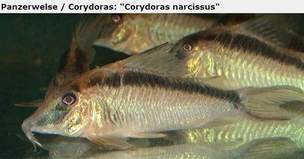](http://4.bp.blogspot.com/_JBpekKB3BH8/SQmXPqo6rTI/AAAAAAAAAok/vz3jEsepC3E/s1600-h/imagem44.JPG)

[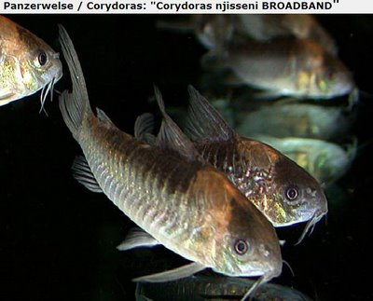](http://4.bp.blogspot.com/_JBpekKB3BH8/SQmW-s-GuyI/AAAAAAAAAoc/4Kx_BUmiQF8/s1600-h/imagem45.JPG)

[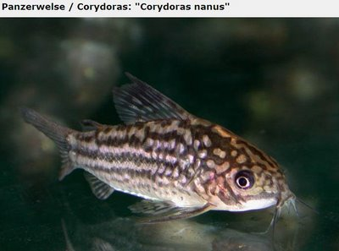](http://2.bp.blogspot.com/_JBpekKB3BH8/SQmW-KjyQhI/AAAAAAAAAoE/UwJenS98b34/s1600-h/imagem42.JPG)

[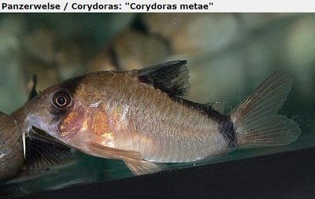](http://2.bp.blogspot.com/_JBpekKB3BH8/SQmW-HOyvUI/AAAAAAAAAn8/IleL9Y2Fm-k/s1600-h/imagem41.JPG)

[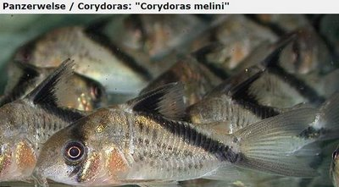](http://4.bp.blogspot.com/_JBpekKB3BH8/SQmW1i_e4hI/AAAAAAAAAn0/iQw-XuK8nQ8/s1600-h/imagem40.JPG)

[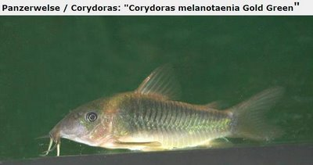](http://1.bp.blogspot.com/_JBpekKB3BH8/SQmW1orTRWI/AAAAAAAAAns/Gt-j-ns13_Y/s1600-h/imagem39.JPG)

[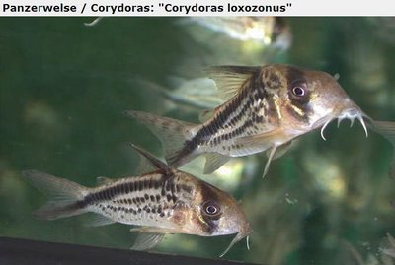](http://4.bp.blogspot.com/_JBpekKB3BH8/SQmW1WwPJMI/AAAAAAAAAnk/1IpcH4Nnf88/s1600-h/imagem38.JPG)

[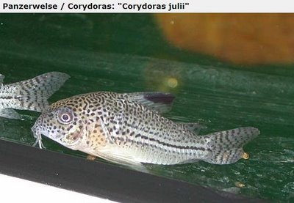](http://2.bp.blogspot.com/_JBpekKB3BH8/SQmW1Km2eZI/AAAAAAAAAnc/sFAD4s8l0ME/s1600-h/imagem37.JPG)

[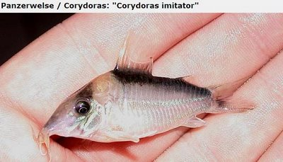](http://3.bp.blogspot.com/_JBpekKB3BH8/SQmW0yaEldI/AAAAAAAAAnU/FSf42MWTv1g/s1600-h/imagem36.JPG)

[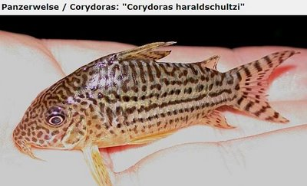](http://2.bp.blogspot.com/_JBpekKB3BH8/SQmWbAqeaAI/AAAAAAAAAnM/VzQfxh_BG88/s1600-h/imagem35.JPG)

[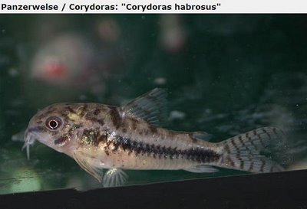](http://1.bp.blogspot.com/_JBpekKB3BH8/SQmWazdWtnI/AAAAAAAAAnE/1kc5mHNOTi0/s1600-h/imagem34.JPG)

[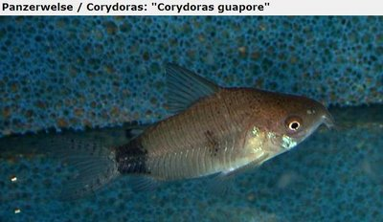](http://2.bp.blogspot.com/_JBpekKB3BH8/SQmWarvYnlI/AAAAAAAAAm8/XbspJvbB0J0/s1600-h/imagem33.JPG)

[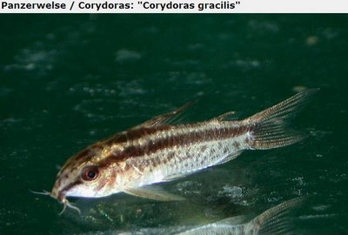](http://2.bp.blogspot.com/_JBpekKB3BH8/SQmWaYLxO-I/AAAAAAAAAm0/6uup6aBIOCY/s1600-h/imagem32.JPG)

[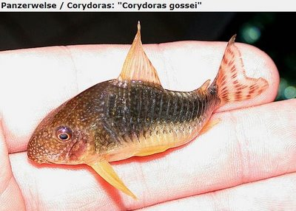](http://3.bp.blogspot.com/_JBpekKB3BH8/SQmWaKindbI/AAAAAAAAAms/dHrbdlG33bU/s1600-h/imagem31.JPG)

[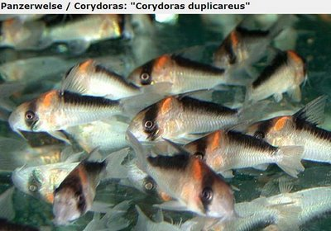](http://1.bp.blogspot.com/_JBpekKB3BH8/SQmWJMJpPEI/AAAAAAAAAmk/-J7cVqRAEpU/s1600-h/imagem30.JPG)

[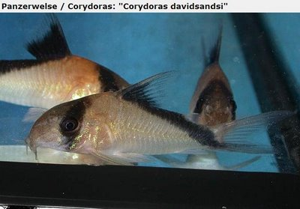](http://3.bp.blogspot.com/_JBpekKB3BH8/SQmWISI2XBI/AAAAAAAAAmc/RIganio2Cq0/s1600-h/imagem29.JPG)

[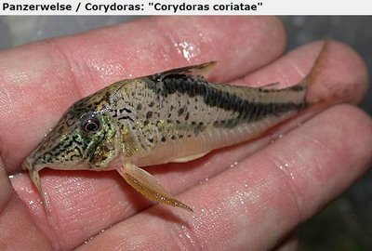](http://3.bp.blogspot.com/_JBpekKB3BH8/SQmWHY2KsUI/AAAAAAAAAmU/bb4QuO_xgQk/s1600-h/imagem28.JPG)

[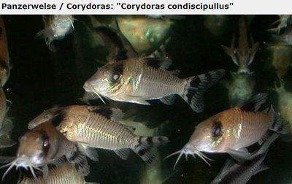](http://4.bp.blogspot.com/_JBpekKB3BH8/SQmWGas_ltI/AAAAAAAAAmM/J6fKV7y4TVg/s1600-h/imagem27.JPG)

[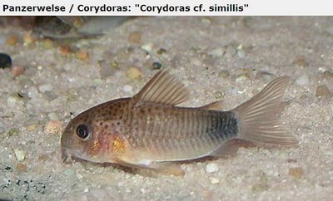](http://3.bp.blogspot.com/_JBpekKB3BH8/SQmWGGUvp3I/AAAAAAAAAmE/Sg4-m7Eotb8/s1600-h/imagem26.JPG)

[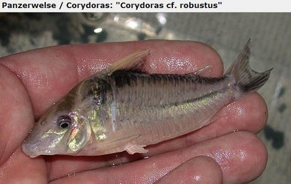](http://3.bp.blogspot.com/_JBpekKB3BH8/SQmV7wKY4NI/AAAAAAAAAl8/MPEjeTXGQAg/s1600-h/imagem25.JPG)

[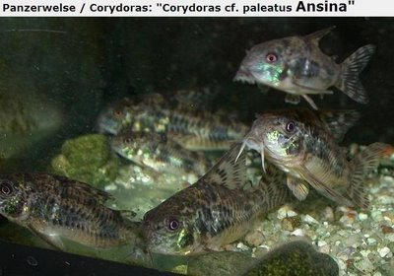](http://1.bp.blogspot.com/_JBpekKB3BH8/SQmV7lyviHI/AAAAAAAAAl0/pm3Ef95tezQ/s1600-h/imagem24.JPG)

[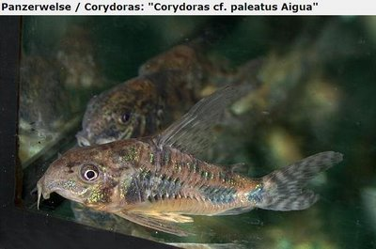](http://4.bp.blogspot.com/_JBpekKB3BH8/SQmV7sjab2I/AAAAAAAAAls/Tya0a0U742E/s1600-h/imagem23.JPG)

[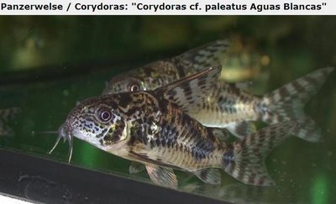](http://3.bp.blogspot.com/_JBpekKB3BH8/SQmV7sXhL9I/AAAAAAAAAlk/AiHl4nluE8g/s1600-h/imagem22.JPG)

[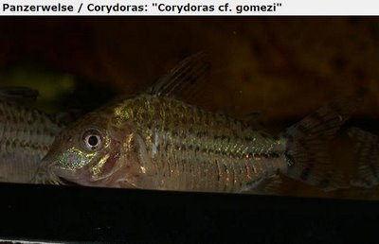](http://1.bp.blogspot.com/_JBpekKB3BH8/SQmV7TA8cfI/AAAAAAAAAlc/gSRBMGcqRyg/s1600-h/imagem21.JPG)

[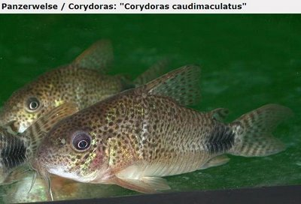](http://2.bp.blogspot.com/_JBpekKB3BH8/SQmVx_gjcNI/AAAAAAAAAlU/dpQvScAvOlo/s1600-h/imagem20.JPG)

[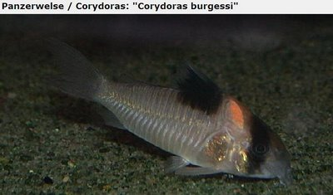](http://1.bp.blogspot.com/_JBpekKB3BH8/SQmVxlPDgQI/AAAAAAAAAlM/EciU3qXdxMM/s1600-h/imagem19.JPG)

[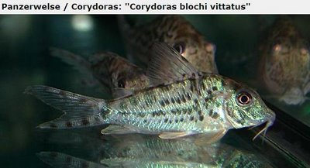](http://1.bp.blogspot.com/_JBpekKB3BH8/SQmVxH75J4I/AAAAAAAAAlE/0ERuOM0dD1o/s1600-h/imagem18.JPG)

[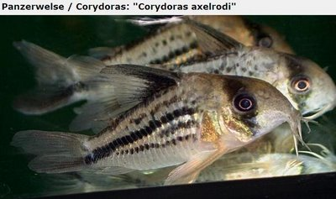](http://4.bp.blogspot.com/_JBpekKB3BH8/SQmVw3_B0UI/AAAAAAAAAk8/rW8Ib6m_E8o/s1600-h/imagem17.JPG)

[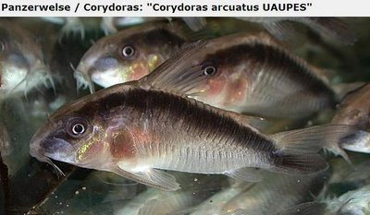](http://4.bp.blogspot.com/_JBpekKB3BH8/SQmVwVMjGoI/AAAAAAAAAk0/77aatClyudk/s1600-h/imagem16.JPG)

[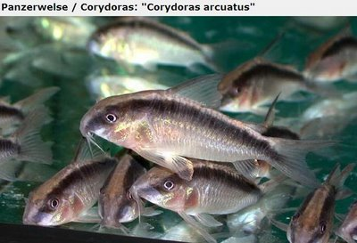](http://4.bp.blogspot.com/_JBpekKB3BH8/SQmVor2WWSI/AAAAAAAAAks/iE0YNxpReUI/s1600-h/imagem15.JPG)

[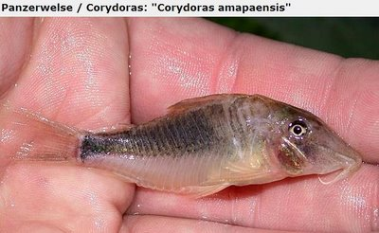](http://2.bp.blogspot.com/_JBpekKB3BH8/SQmVoezlv-I/AAAAAAAAAkk/qtLTA01ovkA/s1600-h/imagem14.JPG)

[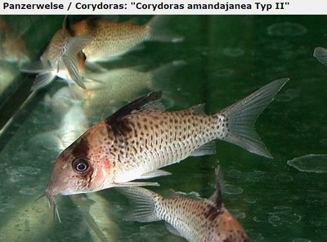](http://3.bp.blogspot.com/_JBpekKB3BH8/SQmVobbCWCI/AAAAAAAAAkc/EKalJdX_GaQ/s1600-h/imagem13.JPG)

[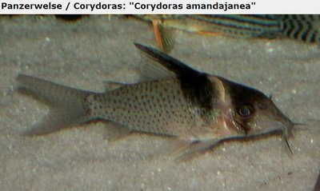](http://3.bp.blogspot.com/_JBpekKB3BH8/SQmVoVkqTyI/AAAAAAAAAkU/iqAGIW_gz94/s1600-h/imagem12.JPG)

[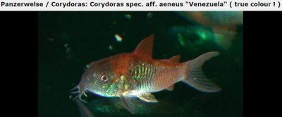](http://3.bp.blogspot.com/_JBpekKB3BH8/SQmVn2OkxkI/AAAAAAAAAkM/qB0pfegxlKk/s1600-h/imagem11.JPG)

[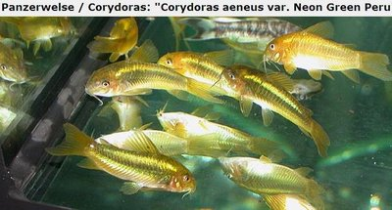](http://2.bp.blogspot.com/_JBpekKB3BH8/SQmVfixICPI/AAAAAAAAAkE/zyQ3QEwS3tg/s1600-h/imagem10.JPG)

[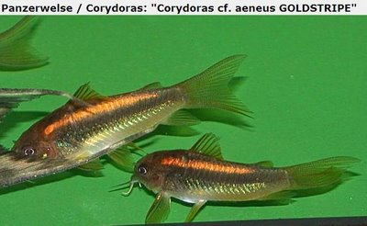](http://4.bp.blogspot.com/_JBpekKB3BH8/SQmVfumKiqI/AAAAAAAAAj8/cIhkw7HTicc/s1600-h/imagem9.JPG)

[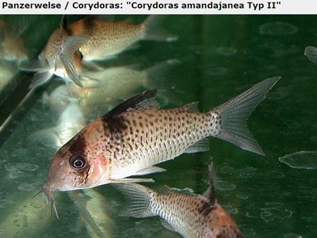](http://1.bp.blogspot.com/_JBpekKB3BH8/SQmVfaE4OVI/AAAAAAAAAj0/JtXuxeKq_Bc/s1600-h/imagem8.JPG)

[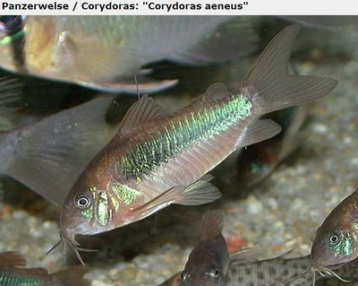](http://3.bp.blogspot.com/_JBpekKB3BH8/SQmVfeiWr_I/AAAAAAAAAjs/WTlRivvFT0g/s1600-h/imagem7.JPG)

[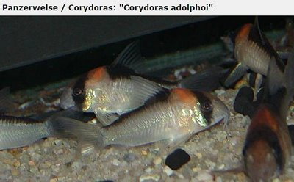](http://2.bp.blogspot.com/_JBpekKB3BH8/SQmVfHl-BgI/AAAAAAAAAjk/HMQPOQPkf98/s1600-h/imagem6.JPG)

[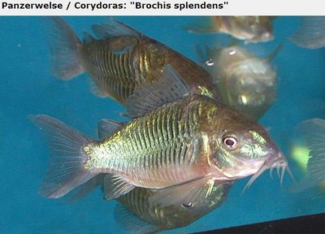](http://2.bp.blogspot.com/_JBpekKB3BH8/SQmVWbhpMjI/AAAAAAAAAjc/WOxcgSWGrxc/s1600-h/imagem5.JPG)

[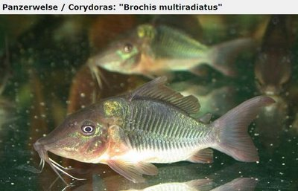](http://4.bp.blogspot.com/_JBpekKB3BH8/SQmVWDZ8zoI/AAAAAAAAAjU/9OySEDdS2Xs/s1600-h/imagem4.JPG)

[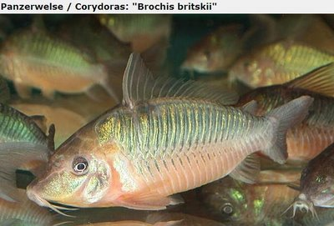](http://4.bp.blogspot.com/_JBpekKB3BH8/SQmVV8nJyfI/AAAAAAAAAjM/Yy_ZyeTqWFs/s1600-h/imagem3.JPG)

[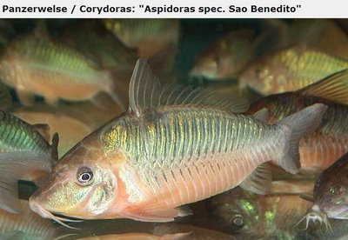](http://2.bp.blogspot.com/_JBpekKB3BH8/SQmVV2CPZqI/AAAAAAAAAjE/B9t3N7VarDE/s1600-h/imagem2.JPG)

[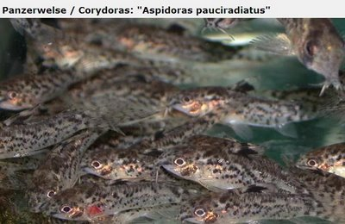](http://4.bp.blogspot.com/_JBpekKB3BH8/SQmVVr5mzpI/AAAAAAAAAi8/gRYXVG2TveE/s1600-h/imagem.JPG)